**MODULE: 6 (Bootstrap Basic & Advance)**

1. What are the advantages of Bootstrap?

Ans. Bootstrap offer many advantage such as saving time and effort by providing ready-made components and styles that can be customized and combined. Its also ensure consistency and compatibility, as it follows a standard design and coding convention , and uses a mobile- first approach

Due to this whole concept, web designing in a limited period is a reality. Besides, it is equipped with free tools, which helps build some common website interface components, thus adding to the adaptability of the framework.

2. What is a Bootstrap Container, and how does it work?

Ans. bootstrap container is used to set the content’s margins dealing with the responsive behaviors of our layout. It contains the row elements and the row elements are the container of columns. The container class is used to create boxed content.

Containers are used for many purposes such as –

• It requires use with the default grid system.

• To establish width for the layout to give web content.

• To provide responsive fixed behavior of any web project.

• To sets the content margin dealing with the responsive behavior of your layout.

there are three types of container classes available in bootstrap:

1. Default-Container(container)

2. Responsive-Container(along with sm, md, lg, xl, xxl)

3. Fluid-Container(container-fluid)

1. Default-Container: The default container uses ‘.container’ class.

Code:

<div class="container">

<!-- Content here -->

</div>

2. Responsive-Container: Responsive containers are responsive in nature.

Code:

<div class="container-sm">Wide for small breakpoint</div>

<div class="container-md">Wide for medium breakpoint</div>

<div class="container-lg">Wide for large breakpoint</div>

<div class="container-xl">Wide for extra large breakpoint</div>

<div class="container-xxl">Wide for extra large breakpoint</div>

3. Fluid-Container: It is used for a full-width container, spanning the entire width of the viewport.

Code:

<div class="fluid-container">

<!-- Content here -->

</div>

* Example1 of .container

Code:

<!DOCTYPE html>

<html lang="en">

<head>

<meta charset="UTF-8">

<meta http-equiv="X-UA-Compatible" content="IE=edge">

<meta name="viewport" content="width=device-width, initial-scale=1.0">

<title>Document</title>

<link rel="stylesheet" href=

"https://maxcdn.bootstrapcdn.com/bootstrap/3.3.6/css/bootstrap.min.css">

<script src=

"https://ajax.googleapis.com/ajax/libs/jquery/1.12.0/jquery.min.js">

</script>

<script src=

"https://maxcdn.bootstrapcdn.com/bootstrap/3.3.6/js/bootstrap.min.js">

</script>

</head>

<body>

<div class="container"

style="background-color: pink;">

<h1>Default-Container</h1>

<p>

example of

container in bootstrap

</p>

</div>

</body>

</html>

Output:

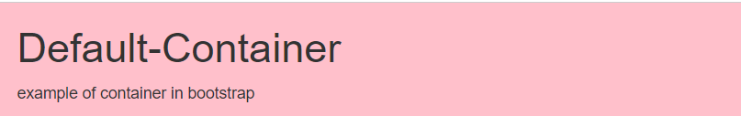

* Example2 of . responsive-container

Code:

<!DOCTYPE html>

<html lang="en">

<head>

<meta charset="UTF-8">

<meta http-equiv="X-UA-Compatible" content="IE=edge">

<meta name="viewport" content="width=device-width, initial-scale=1.0">

<title>Document</title>

<link rel="stylesheet" href=

"https://maxcdn.bootstrapcdn.com/bootstrap/3.3.6/css/bootstrap.min.css">

<script src=

"https://ajax.googleapis.com/ajax/libs/jquery/1.12.0/jquery.min.js">

</script>

<script src=

"https://maxcdn.bootstrapcdn.com/bootstrap/3.3.6/js/bootstrap.min.js">

</script>

</head>

<body>

<div class=" container container-sm"

style="background-color: burlywood;">

<h1>Responsive-Container</h1>

<p>

This is the example of

Responsive-Container

</p>

</div>

</body>

</html>

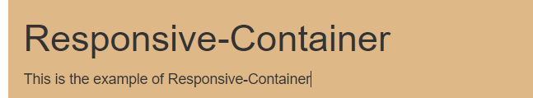

Example3 of . Fluid-Container

Code:

<!DOCTYPE html>

<html lang="en">

<head>

<meta charset="UTF-8">

<meta http-equiv="X-UA-Compatible" content="IE=edge">

<meta name="viewport" content="width=device-width, initial-scale=1.0">

<title>Document</title>

<link rel="stylesheet" href=

"https://maxcdn.bootstrapcdn.com/bootstrap/3.3.6/css/bootstrap.min.css">

<script src=

"https://ajax.googleapis.com/ajax/libs/jquery/1.12.0/jquery.min.js">

</script>

<script src=

"https://maxcdn.bootstrapcdn.com/bootstrap/3.3.6/js/bootstrap.min.js">

</script>

</head>

<body>

<div class=" container-fluid"

style="background-color: azure;">

<h1>Fluid-Container</h1>

<p>

This is the example of

Fluid-Container

</p>

</div>

</body>

</html>

Output:



3. What are the default Bootstrap text settings?

Ans.

1).text-primary, .text-secondary, .text-success, .text-danger, .text-warning, .text-info, 2).text-light, .text-dark, .text-body, .text-white: Sets the text color to one of the predefined contextual colors.

3).text-left, .text-center, .text-right, .text-justify, .text-nowrap: Controls text alignment.

4).text-lowercase, .text-uppercase, .text-capitalize: Controls text transformation (lowercase, uppercase, capitalize).

5).font-weight-bold, .font-weight-bolder, .font-weight-normal, .font-weight-light, .font-weight-lighter: Sets the font weight.

6).font-italic: Makes the text italic.

7).text-decoration-none: Removes text decoration (e.g., underlines).

8).text-break, .word-break, .text-truncate: Controls text wrapping and truncation.

* Example:

<!DOCTYPE html>

<html lang="en">

<head>

<meta charset="UTF-8">

<meta name="viewport" content="width=device-width, initial-scale=1.0">

<!-- Link to Bootstrap CSS -->

<link href="https://cdn.jsdelivr.net/npm/bootstrap@5.0.2/dist/css/bootstrap.min.css" rel="stylesheet">

<title>Bootstrap Text Example</title>

</head>

<body>

<p class="text-muted"> muted text.</p>

<p class="text-primary">primary text.</p>

<p class="text-center"> centered.</p>

<p class="font-weight-bold"> bold.</p>

<p class="font-italic">italic.</p>

<p class="text-decoration-none"> no decoration.</p>

<p class="text-break">This is a long text that will break onto a new line if needed.</p>

<p class="text-truncate" style="width: 150px;">This is a long text that will be truncated with an ellipsis if it exceeds a certain width.</p>

<!-- Bootstrap JS and Popper.js (required for some Bootstrap components) -->

<script src="https://cdn.jsdelivr.net/npm/bootstrap@5.0.2/dist/js/bootstrap.bundle.min.js"></script>

</body>

</html>

4. What do you know about the Bootstrap Grid System?

Ans.

**Row**: Inside the container, you create rows using the .row class. Rows are used to group columns together and ensure proper spacing.

**Column**: Columns are the building blocks of the grid system. You create columns within rows, and each column is specified with a class that indicates the number of columns it should span out of the 12 available columns. For example, .col-6 means a column that spans 6 out of 12 columns.

Code:

<!DOCTYPE html>

<html lang="en">

<head>

<meta charset="UTF-8">

<meta name="viewport" content="width=device-width, initial-scale=1.0">

<!-- Link to Bootstrap CSS -->

<link href="https://cdn.jsdelivr.net/npm/bootstrap@5.0.2/dist/css/bootstrap.min.css" rel="stylesheet">

<title>Bootstrap Grid Example</title>

</head>

<body>

<div class="container">

<!-- Row 1 -->

<div class="row">

<div class="col-12">

<p>This is a full-width column</p>

</div>

</div>

<!-- Row 2 -->

<div class="row">

<div class="col-6">

<p>This is a half-width column</p>

</div>

<div class="col-6">

<p>This is another half-width column</p>

</div>

</div>

<!-- Row 3 -->

<div class="row">

<div class="col-4">

<p>This is a third-width column</p>

</div>

<div class="col-4">

<p>This is another third-width column</p>

</div>

<div class="col-4">

<p>This is the last third-width column</p>

</div>

</div>

</div>

<script src="https://cdn.jsdelivr.net/npm/bootstrap@5.0.2/dist/js/bootstrap.bundle.min.js"></script>

</body>

</html>

5. What is the difference between Bootstrap 4 and Bootstrap 5

Ans. bootstrap 5 has six level xs, sm, md, lg,xl,and xxl. Bootstrap 4 includes jquery and all associated plug-ins.

6. What is a Button Group, and what is the class for a basic Button Group?

Ans. button group is used to create a series of button in groups vertically or horizontally. Class for the button group is btn-group.

Code:

<!DOCTYPE html>

<html lang="en">

<head>

<meta charset="UTF-8">

<meta name="viewport" content="width=device-width, initial-scale=1.0">

<!-- Link to Bootstrap CSS -->

<link href="https://cdn.jsdelivr.net/npm/bootstrap@4.6.0/dist/css/bootstrap.min.css" rel="stylesheet">

<title>Bootstrap Button Group Example</title>

</head>

<body>

<div class="container mt-3">

<h2>Button Group Example</h2>

<!-- Basic Button Group -->

<div class="btn-group" role="group" aria-label="Basic example">

<button type="button" class="btn btn-primary">Button 1</button>

<button type="button" class="btn btn-secondary">Button 2</button>

<button type="button" class="btn btn-success">Button 3</button>

</div>

</div>

<!-- Bootstrap JS and Popper.js (required for some Bootstrap components) -->

<script src="https://cdn.jsdelivr.net/npm/bootstrap@4.6.0/dist/js/bootstrap.bundle.min.js"></script>

</body>

</html>

Output:

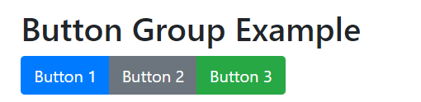

7. How can you use Bootstrap to make thumbnails?

Ans. To create thumbnail using bootstrap, you can use the ‘.img-thumbnail’ class on an <img> element to automatically style and size the image as a thumbnail.

Code:

<!DOCTYPE html>

<html lang="en">

<head>

<meta charset="UTF-8">

<meta name="viewport" content="width=device-width, initial-scale=1.0">

<link href="https://cdn.jsdelivr.net/npm/bootstrap@4.6.0/dist/css/bootstrap.min.css" rel="stylesheet">

<title>Bootstrap Thumbnails Example</title>

</head>

<body>

<div class="container mt-3">

<h2>Thumbnail Example</h2>

<div class="row">

<div class="col-md-4">

<a href="#">

<img src="https://via.placeholder.com/150" alt="Thumbnail 1" class="img-thumbnail">

</a>

</div>

<div class="col-md-4">

<a href="#">

<img src="https://via.placeholder.com/150" alt="Thumbnail 2" class="img-thumbnail">

</a>

</div>

<div class="col-md-4">

<a href="#">

<img src="https://via.placeholder.com/150" alt="Thumbnail 3" class="img-thumbnail">

</a>

</div>

</div>

</div>

<script src="https://cdn.jsdelivr.net/npm/bootstrap@4.6.0/dist/js/bootstrap.bundle.min.js"></script>

</body>

</html>

Output:

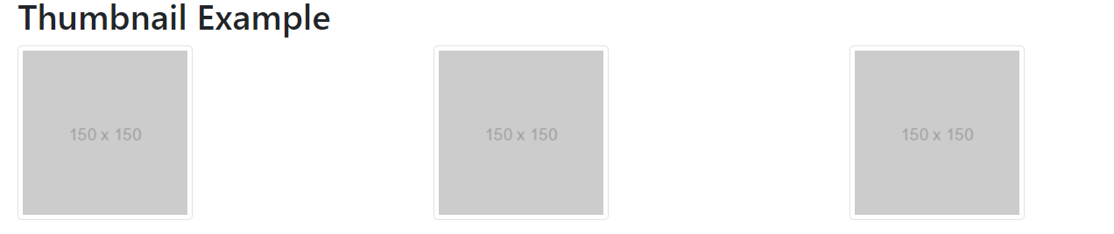

8. In Bootstrap 4, what is flexbox?

Ans. in bootstrap 4 , flexbox is a layout system that provides an efficient way to arrange and align elements within a container, enabling responsive and dynamic design.

Code:

<! DOCTYPE html>

<html lang="en">

<head>

<title> Bootstrap 4 vertical Flex Box Example </title>

<meta charset="utf-8">

<meta name="viewport" content="width=device-width, initial-scale=1">

<link rel="stylesheet" href="https://maxcdn.bootstrapcdn.com/bootstrap/4.5.2/css/bootstrap.min.css">

<script src="https://ajax.googleapis.com/ajax/libs/jquery/3.5.1/jquery.min.js"> </script>

<script src="https://cdnjs.cloudflare.com/ajax/libs/popper.js/1.16.0/umd/popper.min.js"> </script>

<script src="https://maxcdn.bootstrapcdn.com/bootstrap/4.5.2/js/bootstrap.min.js"> </script>

</head>

<style>

h2 {

position: relative;

padding: 10;

margin: 10;

font-family: "Raleway", sans-serif;

font-weight: 300;

font-size: 40px;

color: white;

text-align: center;

-webkit-transition: all 0.4s ease 0s;

-o-transition: all 0.4s ease 0s;

transition: all 0.4s ease 0s;

}

body {

background-size: 400% 400%;

margin: 2rem;

background: linear-gradient(-45deg, #ee7752, #e73c7e, #23a6d5, #23d5ab);

animation: gradient 15s ease infinite;

height: 100vh;

}

@keyframes gradient {

0% {

background-position: 0% 50%;

}

50% {

background-position: 100% 50%;

}

100% {

background-position: 0% 50%;

}

}

</style>

<body>

<div class="container mt-3">

<h2> Bootstrap 4 Vertical Direction flexbox </h2>

<p> Use .flex-column-reverse to reverse the vertical direction: </p>

<div class="d-flex flex-column-reverse">

<div class="p-2 bg-info"> Flex 1 </div>

<div class="p-2 bg-warning"> Flex 2 </div>

<div class="p-2 bg-primary"> Flex 3 </div>

</div>

</div>

</body>

</html>

Output:

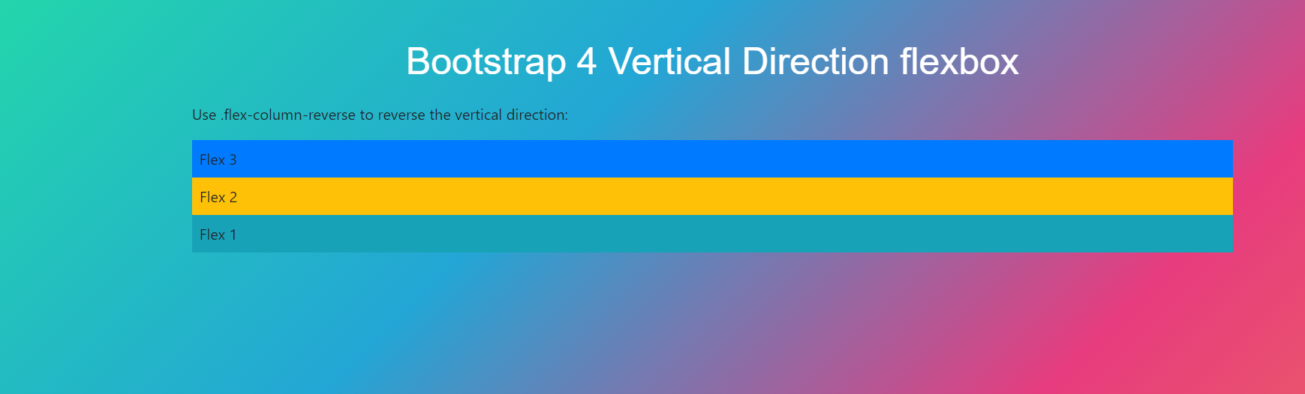

9. How can one create an alert in Bootstrap?

Ans. Bootstrap provide an easy way to create an alert message in bootstrap.

Ex.

<!DOCTYPE html>

<html lang="en">

<head>

<meta charset="UTF-8">

<meta name="viewport" content="width=device-width, initial-scale=1.0">

<!-- Link to Bootstrap CSS -->

<link href="https://cdn.jsdelivr.net/npm/bootstrap@5.0.2/dist/css/bootstrap.min.css" rel="stylesheet">

<title>Bootstrap Alert Example</title>

</head>

<body>

<div class="container mt-3">

<!-- Success Alert -->

<div class="alert alert-success" role="alert">

This is a success alert!

</div>

<!-- Info Alert -->

<div class="alert alert-info" role="alert">

This is an info alert!

</div>

<!-- Warning Alert -->

<div class="alert alert-warning" role="alert">

This is a warning alert!

</div>

<!-- Danger Alert -->

<div class="alert alert-danger" role="alert">

This is a danger alert!

</div>

</div>

<script src="https://cdn.jsdelivr.net/npm/bootstrap@5.0.2/dist/js/bootstrap.bundle.min.js"></script>

</body>

</html>

Output:

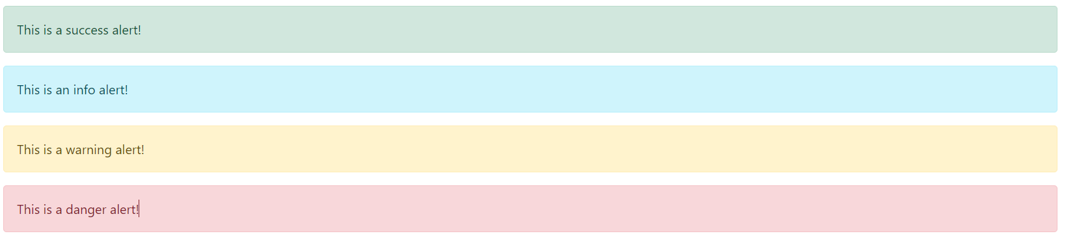

10. What is a bootstrap card and how would you create one?

Ans.

<!DOCTYPE html>

<html lang="en">

<head>

<meta charset="UTF-8">

<meta http-equiv="X-UA-Compatible" content="IE=edge">

<meta name="viewport" content="width=device-width, initial-scale=1.0">

<title>Document</title>

<link href="https://cdn.jsdelivr.net/npm/bootstrap@5.0.2/dist/css/bootstrap.min.css" rel="stylesheet" integrity="sha384-EVSTQN3/azprG1Anm3QDgpJLIm9Nao0Yz1ztcQTwFspd3yD65VohhpuuCOmLASjC" crossorigin="anonymous">

<script src="https://cdn.jsdelivr.net/npm/@popperjs/core@2.9.2/dist/umd/popper.min.js" integrity="sha384-IQsoLXl5PILFhosVNubq5LC7Qb9DXgDA9i+tQ8Zj3iwWAwPtgFTxbJ8NT4GN1R8p" crossorigin="anonymous"></script>

<script src="https://cdn.jsdelivr.net/npm/bootstrap@5.0.2/dist/js/bootstrap.min.js" integrity="sha384-cVKIPhGWiC2Al4u+LWgxfKTRIcfu0JTxR+EQDz/bgldoEyl4H0zUF0QKbrJ0EcQF" crossorigin="anonymous"></script>

</head>

<body>

<div class="card" style="width: 18rem;">

<img src="https://pbs.twimg.com/profile_images/1317386879105290240/ZBL8ZiZ-_400x400.jpg" class="card-img-top" alt="...">

<div class="card-body">

<h5 class="card-title">harsand Mehta</h5>

<p class="card-text">Some quick example text to build on the card title and make up the bulk of the card's content.</p>

<a href="#" class="btn btn-primary">Go somewhere</a>

</div>

</div>

</body>

</html>

Output:

